**DAY 8 ASSIGNMENT LINUX ADMIN LU**

**Assignment 0**

**1. Create a simple shell script to tell the user about their session – they**

**need to know:**

**● What their username is**

**● What the current date is**

**● What the time is**

**● What their current working directory is**

**● How many files they have in that directory**

**● What is the biggest file in their current directory**

**Assignment 1**

**Create a directory with a few test files in it (the files can be empty). Now write a script that for**

**every file in that directory you rename it to have an extension of today's date in YYYYMMDD**

**format.**

**Assignment 2**

**Write a script that takes a number as an input and reverses it out to the user. For example, if the**

**original number is 74985, the output should be 58947.**

**Assignment 0**

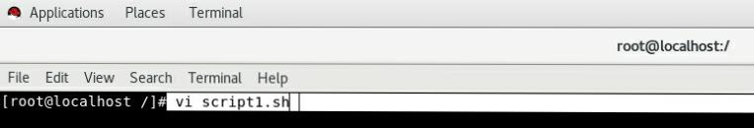Opening Script File

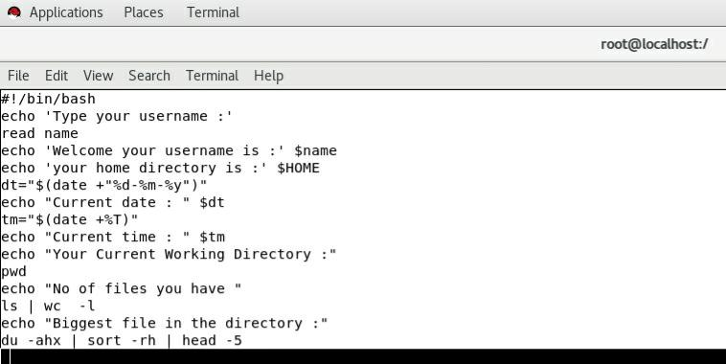Doing Scripting

Output 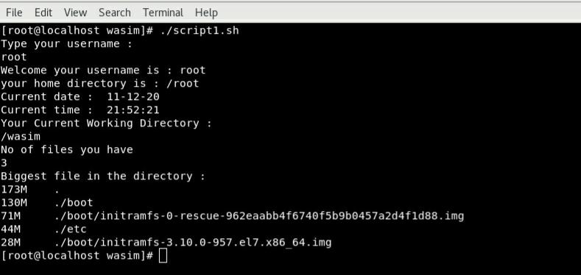

**Assignment 1**

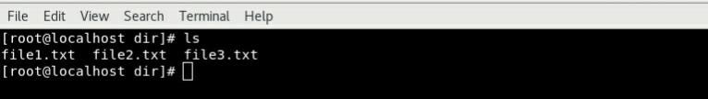Creating Files

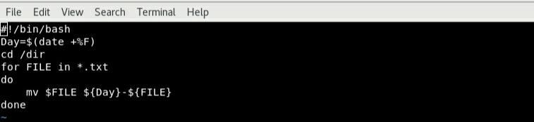Scripting

Output

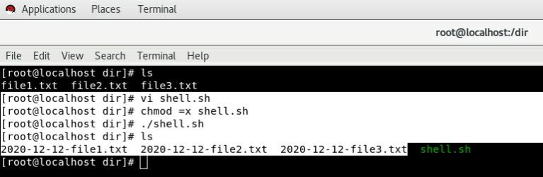

**Assignment 2**

Opening Script File

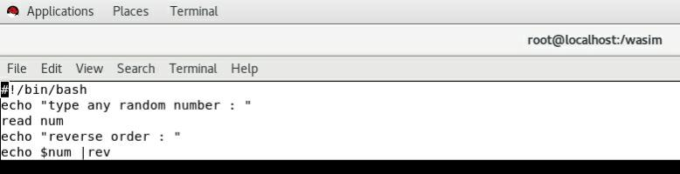Scripting

Output

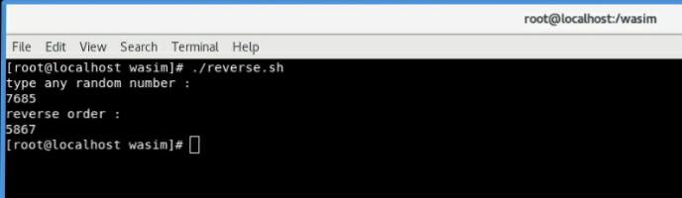

**Assignment 3**

**Here I Have Used Termux Which Is An Android Application For Scripting**

Opening The File

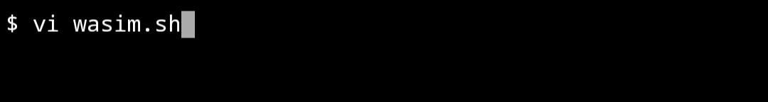

Scripting

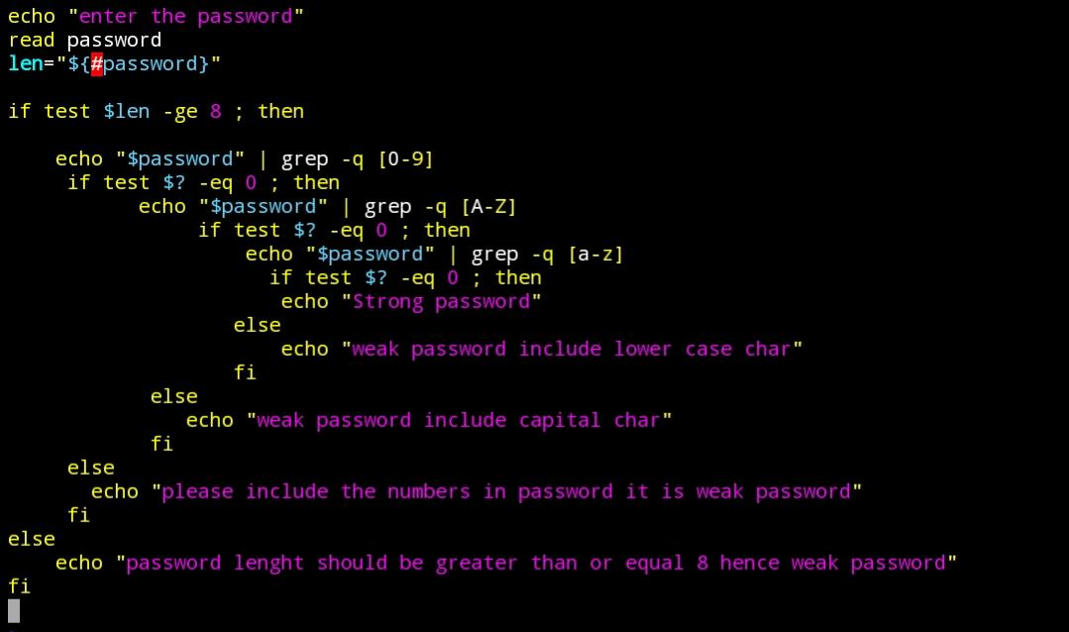

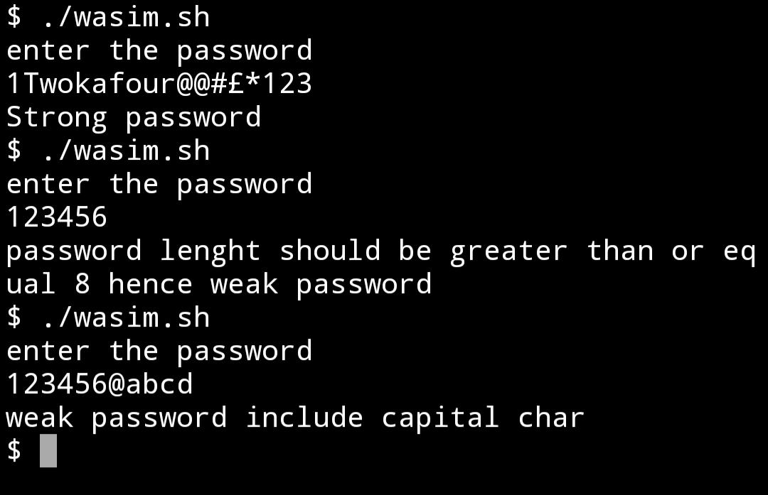Output